**Learning Theory Carnival**

Monday, July 22

7:15-9:15 pm

**PROTOCOL**

**BOOTH Five**

**Piaget: Levels and process of cognition**

|  |  |
| --- | --- |
| **Learning GOAL:**  **Participants collaboratively design and conduct pendulum experiment and reflect on how the experiment relates to cognitive constructivism and how learners at different stages of development might approach this experiment.** | |
| **Directions**   1. **Observe the poster of constructivism. Pay close attention to the cognitive constructivism side of the poster. Also observe the second poster of Piaget’s fours stages** 2. **Directions:**     1. **Work in pairs to conduct an experiment. Your task is to determine which factor is the most important in determining the speed of swing of the pendulum.**    2. **Begin the experiment by making a hypothesis. What factor is most important in determining the speed of swing:**       1. **Length of rope**       2. **Weights**       3. **Force of the push**    3. **As a group, design your approach to the experiment. How will you test your hypothesis?**    4. **Conduct your experiment.**    5. **What are your conclusions?** 3. **To debrief:**    1. **Return to the constructivist image and discuss how this lesson incorporated the concepts and principles of cognitive constructivism.**    2. **Return to the second image. What might be some differences in the way students in the concrete operational stage and students in the formal operational stage approach this experiment?** 4. **STAMP/GIVE STICKER (?) the CARNIVAL BOOKLET** | |
| **Activities**   1. **The group observes the poster of cognitive constructivism and the poster of Piaget’s four stages. Ask: What do you observe about cognitive constructivism? About the four stages?** 2. **Each group gets materials to conduct the pendulum experiment.** 3. **Groups hypothesize and then conducts experiment.** 4. **Group determines conclusions.** 5. **Group discusses how this represents cognitive constructivism and why we need this theory in our understanding of learning. What kind of learning does cognitive constructivism represent and why is it important for our students** | **Materials**   * **Pendulum Frame** * **String – 3 different lengths** * **Washers – 5 different washers** |

[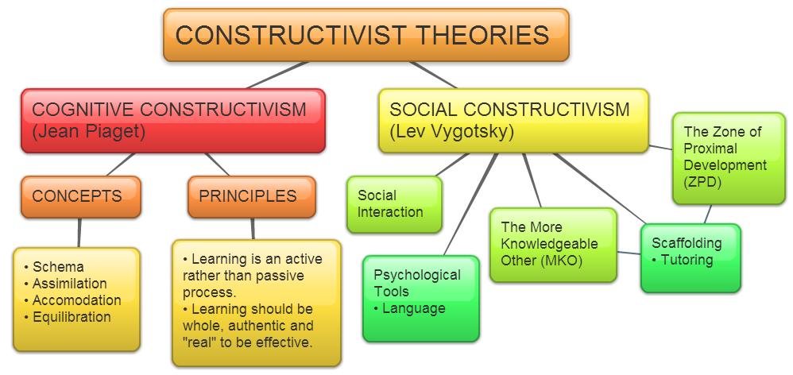](https://owelpapel.wordpress.com/tag/notes-and-resources/)

